ITEC 7460 Professional Learning and Technology Innovations:
Assignment 1: Current Reality and GSAPS
Jamey N. Bearden
Kennesaw State University

Introduction

I interviewed the CTAE Director to get a better understanding of the process behind professional development and technology implementation at Dawson County High School. I also spoke with faculty members from a variety of content areas to have a broadened view of the role of technology implementation.
The technology mission statement that was identified in Commitment 7 of the Dawson County Schools Mission and Vision Statement, “Integrating current and emerging technologies to compete in the 21st century” (Mission 1). This statement vaguely summarizes that at DCHS we are incorporating and using technology more and more in our classrooms. Our goal is to continue to do so, in an effective and meaningful way.

Strategies

Professional learning is provided in various ways, from sharing ideas and information through online tools in professional learning networks, to Wednesday workshops, to after school meeting and classes. Professional learning needs for schools and the system are determined through survey results and by school and system stakeholders. Professional learning (PL) is targeted with different goals and topics to different groups as needed. PL is differentiated for the different needs of our staff. Decisions are made through a staff survey conducted at the end of each school year, along with observational data that administration use.
This year at DCHS, several types of professional learning opportunities were provided. The focus topics of professional learning included FIP, MAX Strategies, and Classworks. These topics and implementation strategies were emphasized within the Special Education, English and Mathematics Departments. The need for development and training in these strategies and areas was determined by an end-of -year survey in spring 2015. The need for teachers to implement and be more skillful in these strategies is directly aligned to the School Improvement Plan that was updated Fall 2015. Administration as well as representatives from Pioneer RESA conducted the workshops during Wednesday Workshops and In-Service Days.
Technology-related professional learning topics included “mini” Wednesday Workshop sessions on Google Drive, Classworks (for teachers of specific subject areas), SMARTBoards, and Schoology. These workshops are conducted by both administrators (Classworks) and teachers (Google Drive and Schoology).

Differentiated Professional Learning
At DCHS, there is also specific professional learning for teachers with special needs students and for teachers who have students from culturally and linguistically diverse backgrounds. Training for these teachers include: Mindset training and ESOL Training. Mindset training is provided by administration and RESA and usually is conducted during the school day and is available to the entire system. ESOL training is provided by our DCHS ESOL Liason and teacher. The entire faculty participates in an ESOL overview training session, while the teachers who have ESOL students participate in more in-depth training. This training usually occurs after school or during in-service days. Both types of training include individualized follow-up.

Follow-up

A very important aspect to professional learning after the information/topic is presented in follow-up. Follow-up ensures that teachers know how and when to implement the strategies or technology discovered in Professional Learning.
Follow-up for the professional learning workshops at DCHS occurred in a few ways. For FIP and Max Strategies training, teachers were required to keep logs with information regarding when, how and reflections of incorporated strategies and techniques. Then the teachers involved in these training sessions would then report their findings and implementation experiences back to the group at the next meeting.
For Classworks, follow-up was more in the form of a trial and error process. Classworks has been implemented at the Middle School Level and training begun this year DCHS. It was more of a tutorial and then follow-up involved question and answer sessions to improve better use and a smoother implementation.
For Google training, follow-up was very low-key and involved sending feedback and questions to the teachers who conducted the workshops for additional info and help. SMART training and feedback were also conducted and followed-up in the same way.
For Schoology training, basic tutorial information was presented and teachers followed up with individualized questions and sessions to learn more about implementation and usage. Websites were also provided to assist in the tutorial process.
Another form of follow-up is also provided through the TKES Evaluation Process. Teachers can demonstrate their knowledge and means of implementation of these strategies during teacher observations conducted by administration. Administration can offer feedback during the feedback and evaluation step of the TKES process.
Lastly, follow-up is provided through informational weekly email updates sent to all DCHS faculty and staff (in the form of more information or ways to get remediation) and also in our monthly system-wide technology emails that provided additional means of support and information.

School Improvement Goals
Professional Learning is directly aligned to School Improvement Goals at Dawson County High School. The School Improvement Goals of DCHS involve increasing student performance and achievement on various subject-specific EOCs (See Appendices 1-6). Max Strategies and FIP were specifically offered to English, Math and Special Education teachers to help improve these test scores and overall student performance in these areas. Social Studies and Science Teachers received these training sessions last year for the same purpose and goals in mind. These strategies are already being incorporated and follow-up is still being provided on an individualized-basis.

Collaborative Learning Communities
At DCHS, Collaborative Learning Communities are based on content and curriculum areas. Teachers meet within departments and then by subject-area and/or grade level taught. Professional Learning is also divided up in this way. By dividing CLC in this way, professional learning is directly aligned to the School Improvement Plan Goals and Initiatives (see Appendices 1-6). Follow-up and feedback is provided within these groups as well as by administration during TKES observations and on an as-needed basis.
Funding
Professional Learning at Dawson County Schools and DCHS is provided through various means. Pioneer RESA offers free professional learning services and training because of member consortium. DCHS’ General Fund Account pays for Max Strategies supplies, while in-house administrators and teachers conduct training. The System Professional Development Fund funds FIP, Classworks, Mindset, ESOL Training, and any other Professional Learning that is system-wide. Since Schoology and Google Drive training was provided by DCHS teachers, it is free of charge.
Incentives
The obvious incentive is for teachers to participate in professional practice and improve their practice is student learning. As a teacher, it is imperative that students perform at their best. If there are certain strategies that are proven to increase student performance and achievement, then they will be incorporated. By incorporating these technologies and strategies, it allows for a better working process. It also allows for a better learning environment for students.
Differentiated Professional Learning
At DCHS, there is also specific professional learning for teachers with special needs students and for teachers who have students from culturally and linguistically diverse backgrounds. Training for these teachers include: Mindset training and ESOL Training. Mindset training is provided by administration and RESA and usually is conducted during the school day and is available to the entire system. Our DCHS ESOL Liaison and teacher provide ESOL training. The entire faculty participates in an ESOL overview training session, while the teachers who have ESOL teachers participate in more in-depth training. This training usually occurs after school or during in-service days. Both types of training include individualized follow-up.
Implementation and Evaluation
The impact of professional learning on teacher practice and student learning is evaluated through lesson plan documentation, student achievement scores, test scores and benchmarks. Implementation can also be found through teacher observations and discussions and feedback session in professional learning community meetings.
Conclusion
The professional learning process is highly functioning and implemented at DCHS. Multiple as well as differentiated training is provided to teachers in a variety of ways. Teachers receive feedback via individualized sessions, newsletters, discussions and through the teacher observation process. I believe that DCHS has a strong grasp on professional learning and improving student achievement through professional learning. Professional Learning is also directly aligned with DCHS’ School Improvement Plan to directly improve student achievement.

Appendix 1: Goal 1, Initiative 3
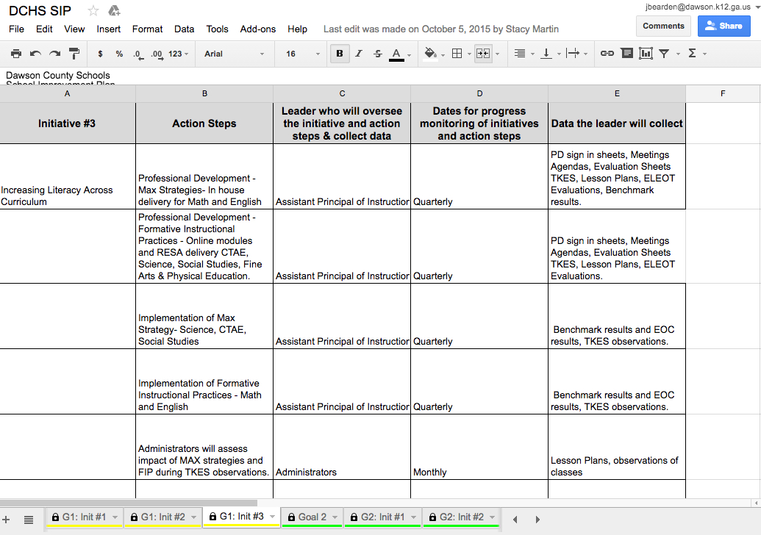
Appendix 2: Goal 2, Initiative 1
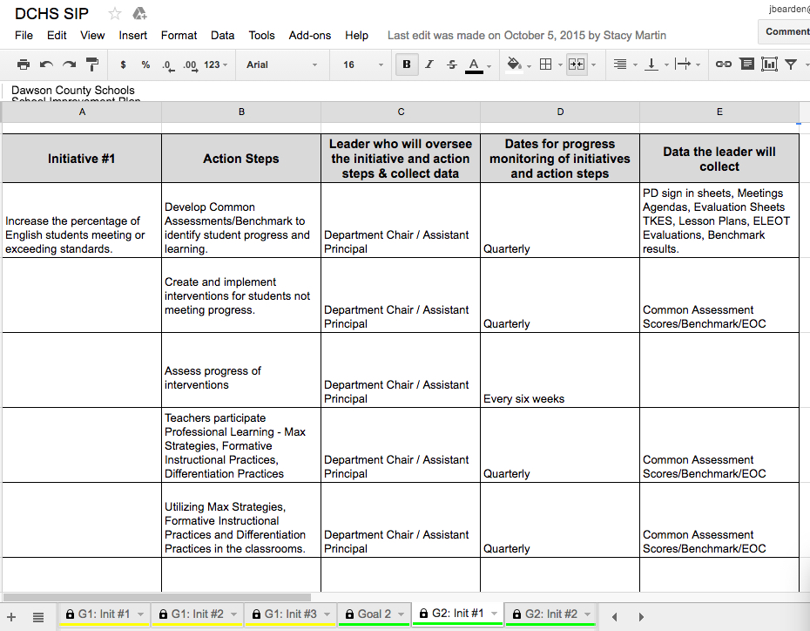

Appendix 3: Goal 2, Initiative 2
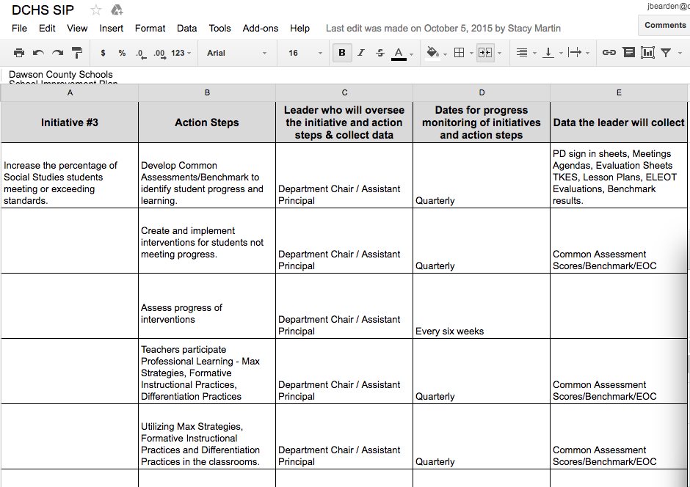

Appendix 4: Goal 2, Initiative 4
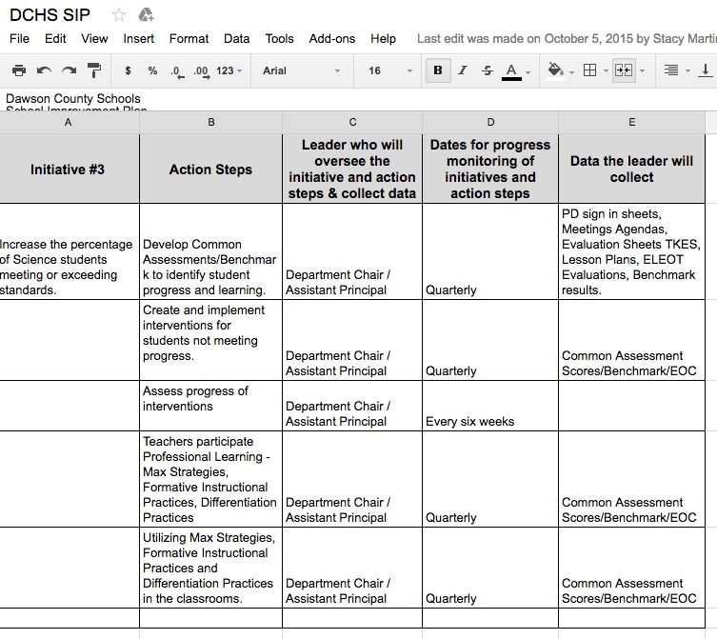
Appendix 5: Goal 2, Initiative 5
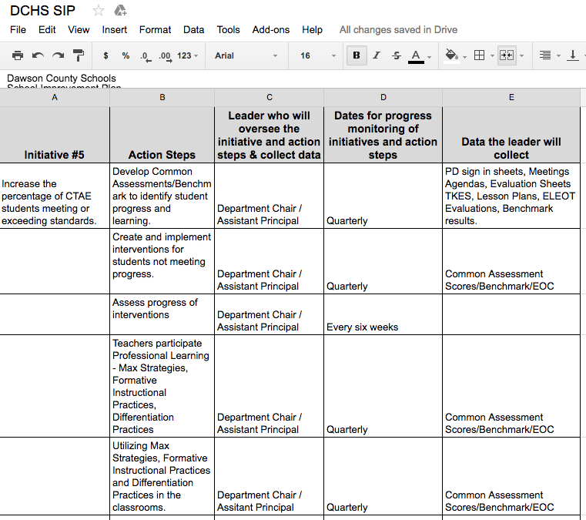
Appendix 6: Goal 3, Initiative 2
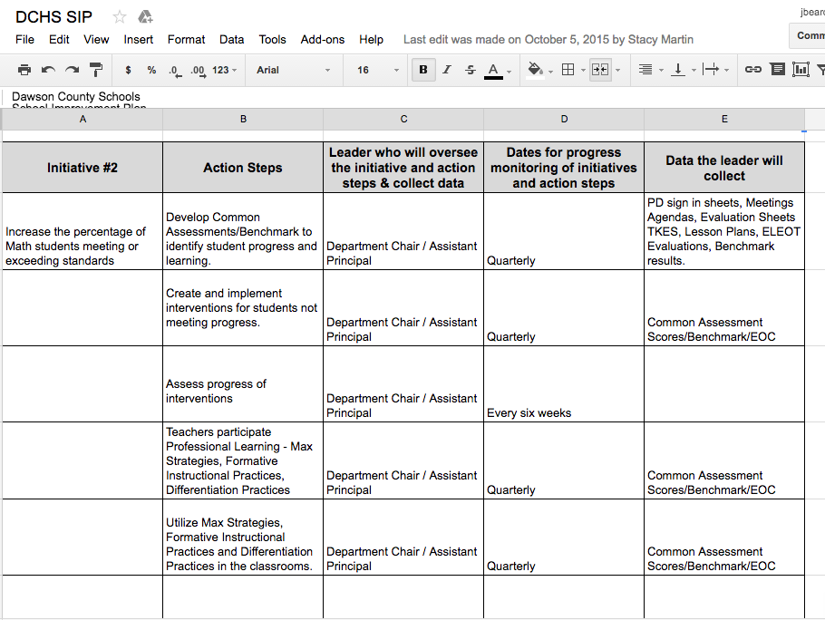
References

Dawson County Schools. Dawson County School Systems Mission and Vision Statement.
http://www.dawsoncountyschools.org/about_d_c_s_s/mission_and_vision

Dawson County High School. Dawson County High School School Improvement Plan 2015-
2016. Accessed through Google Docs.

