ITEC 7460 Professional Learning and Technology Innovations:
Assignment 2: Individualized Assessment
Jamey N. Bearden
Kennesaw State University

Introduction

I conducted two surveys regarding technology-based professional learning amongst a small population of the staff at Dawson County High School. The purpose of these surveys is to identify areas of need and areas of improvement amongst teachers regarding technology. The surveys’ responses provided feedback that I reported to administration to hopefully provide feedback in regards to teachers’ technology use and needs improvement areas.

Assessments

The two tools used to assess technology needs amongst staff at Dawson County High School were developed by myself and my ITEC 7460 PL Group. The two surveys are included at the end of this document as Appendix 1 and Appendix 2. The Survey in Appendix A addresses LoTi-type questions while the survey in Appendix B addresses Adopter categories as described by Rogers Change Theory.

Loti Survey Results

The following is a summary of the results from the LoTi suvey (see Appendix A), question by question:
- In Question 1, “As a teacher, I know how to do the following (check all that apply),” all teachers could create documents, spreadsheets, use email, teachers could use social media, use online learning tools and create standards-based assessments. However, only 2 could use technology to analyze data. Four people could participate in and conduct online discussions and knew how to create and use blogs. No one could make a screencast.
- In Question 2, “Indicate which technologies you have in your classroom and the frequency with which you use it,” everyone indicated that they have a teacher laptop, SMARTBoard, computer projector, TV, DVD Player, and WiFi connection for both teachers and students.
- In Question 3, “My students utilize the following Web 2.0 tools as part of my classroom curriculum,” teachers responded that students create documents, spreadsheets and presentations, participate in online games, create spreadsheets and use the Internet often for research. However most of them responded that they do not participate in online blogs or discussions, utilize collaborative tools such as Google docs or classroom social networks or social media.
- In response to Question 4, “As a teacher, I incorporate the following 21st century skills into my classroom curriculum,” 3 teachers stated that they incorporate all of these tools once in a while, while 2 of them stated that they only incorporate collaboration, creativity, critical thinking and communication and that they do these things weekly.
- In Question 5, “I use the following tools to keep parents informed of classroom learning and events (including grades) in my classroom,” all teachers surprisingly responded that they use Remind 101/Edmodo and email once in awhile, and they never use the other tools to keep parents informed.
- In Question 6, “What area would you like to see technology impact the MOST in our schools?” 3 teachers responded for meeting personalized needs of the students and 2 teachers responded to increase student achievement on standardized tests.
- In Question 7, “I attend professional development and/or seek technology support from__________,” all teachers responded with on-campus services and from colleagues. Only 1 said off campus workshops/conferences and instructional team meeting, while 3 people responded with online.
- In reference to Question 8, “I am aware of my school's technology vision and action plan,” no one is aware of the technology vision plan.
- In response to Question 9, “I would be interested in collaborating with an Instructional Technology Coach,” everyone responded “absolutely.”
- In Question 10, “If you answered "maybe" or "absolutely yes" to the above question, with which method of delivery would you feel most comfortable for collaboration?” everyone checked “in person/one-on-one” and 3 people checked podcast tutorials. Two people also checked “small groups group specific.”

Overall feedback from the LoTi survey suggests that teachers are incorporating some 21st
Century technology tools in their classrooms. They seem to mainly use these tools for production (documents, presentations, etc.) and perhaps are not utilizing more meaningful tools because of lack of knowledge or being comfortable using them in their classrooms.

Adopter Survey Results
The following is a summary of the results from the Adopter Survey (see Appendix B), question by question:
- In Question 1, “Compared to other people you know, how would you describe yourself?” 4 teachers selected “in the middle” and one checked the “last to know.”

- In Question 2, “I feel like my students are more engaged in my content area if I used or allowed them to regularly use technology in class,” teachers were conflicted. 3 selected “strongly agree” while 2 selected strongly disagree.”
- In Question 3, “I’m more likely to try a new piece of technology in my lesson if…” all teachers said if they “see it modeled.”
- In response to Question 4, “I tend to learn about new technologies,” Everyone responded with “from colleagues”, from “workshops/professional learning” and from “articles.”
- In Question 5, “When it comes to having students use technology for learning, I am…” all teachers responded with “integrating it.”
- Regarding Question 6, “When it comes to implementing technology in general at my school, other teachers come to me for help,” most people were in the middle and a couple responded “disagree.”
- In Question 7, “When it comes to troubleshooting technology-related issues with tools in general at my school, other teachers come to me for help,” all teachers responded “strongly disagree”.
- In response to Question 8, “When it comes to technology implementation in the classroom, I am seen as a leader in my school,” 4 teachers responded in the middle (not a yes, but not a no) and one teacher responded, “agree.”
- In Question 9, “I will go ahead and integrate technology into instructional strategies even if professional development is NOT followed by ongoing support,” all teachers agreed.
- In response to Question 10, “I can tell that my school’s usage of technology is in line with the school’s technology action plan,” teachers responded that they are unaware of the technology action plan.
The overall consensus of the Adopter survey indicates that teachers want to use technology but maybe are uncomfortable fully implementing it. Although it does seem that teachers are willing to get help and are open-minded, just maybe somewhat uninformed.

Interview
I interviewed three of the survey participants, narrowing down my focus to one. The initial interview of the three teachers was conducted in a group setting and was very casual. I asked teachers to elaborate on some of their answers to the questions they were asked. Basically it came down to teachers feeling that they can learn these new technologies, but they are apprehensive. They think that it might be a fad and a “waste of time” to go to such lengths to learn and implement something that might change tomorrow. They are however seemingly positive about implementing technology because they know that it is necessary to keep the attention and capture the focus of today’s students.
Teachers are genuinely worried about the time factor. They do not know how they will be able to allot the time necessary to learn how to effectively implement these tools. They said that they are willing to do so, but do not want it to be a waste and that they want support available to help them troubleshoot.
One teacher was particularly motivated and interested. She was interested in me coaching her and helping her implement meaningful technology into her lessons and the structure of how her class operated and functioned. She said that even though she is very good at using social media on a day to day basis, she struggles with what she should incorporate. She wants to try technology that will be meaningful while also not being a hassle or difficult to deal with. She basically said that she would love to find something like a website that she can “send her students to for resources, tools, etc.” but did not want the effort to outweigh the benefit.

Needs Statement

I have decided to train my colleague on the Learning Management System, Schoology. I believe that utilizing this LMS will meet many of her goals with her students. She can create a class page for each of her classes (although we will trial one), and then add materials as resources. She can also initiate discussions with her students, while moderating their posts if necessary. She can also give formative and summative activities and assessments utilizing Schoology. She can even align the assessments and activities to the GPS. Then I can show her how Schoology analyzes student achievement data. She can set up the calendar to serve as a reminder to students and parents (if she decides to include parent accounts). One area in the survey that was weak was parent contact. I feel that this LMS could offer a solution to that area. Also, since Schoology’s interface is similar to that of Facebook, (which she already uses), I feel that it will be user-friendly and not a “waste of her time.” Hopefully, after coaching her to utilize Schoology with her students, she will feel more comfortable using more 21st Century Teaching Tools.
Conclusion
Teachers at DCHS are incorporating basic technology tools in their classrooms. They want to learn how to incorporate more tools, but they want to be reassured that these tools are meaningful to student learning. Teachers also already feel strapped for time, so they want whatever it is that they need to know to be effective and efficient.

Appendix A
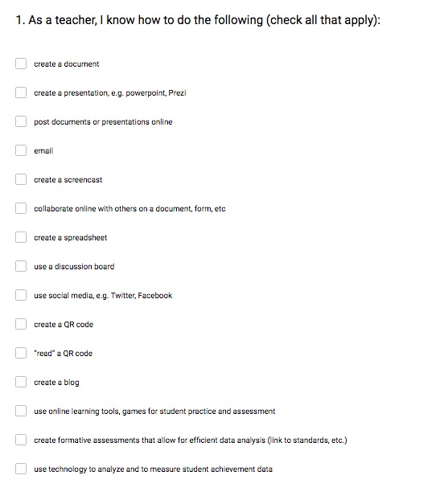
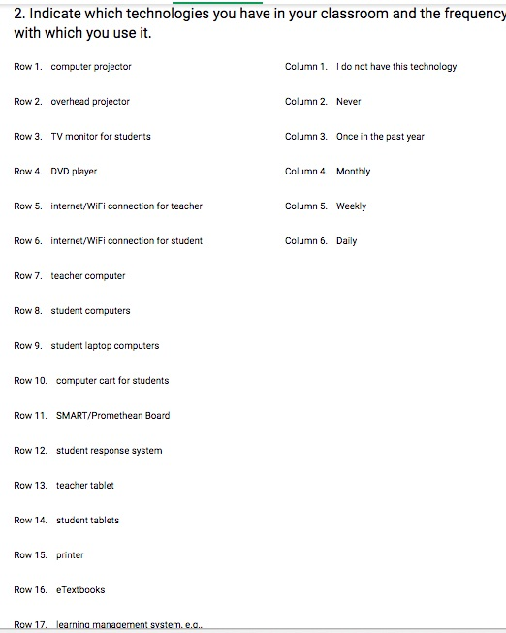
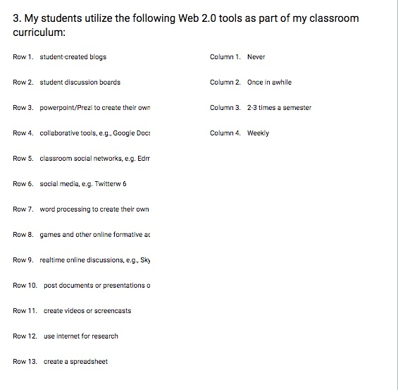
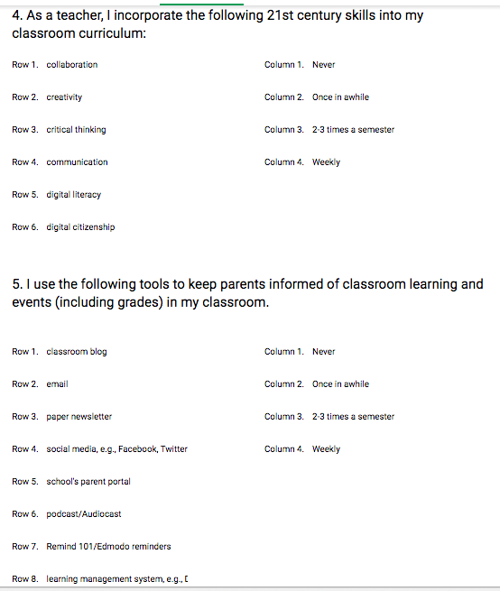

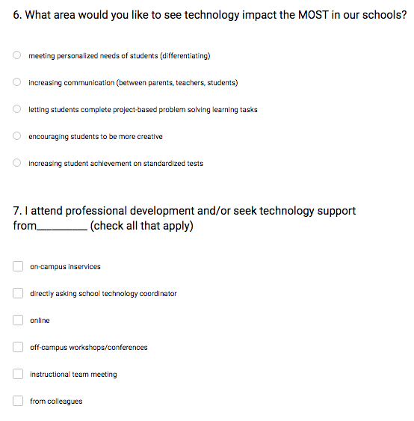
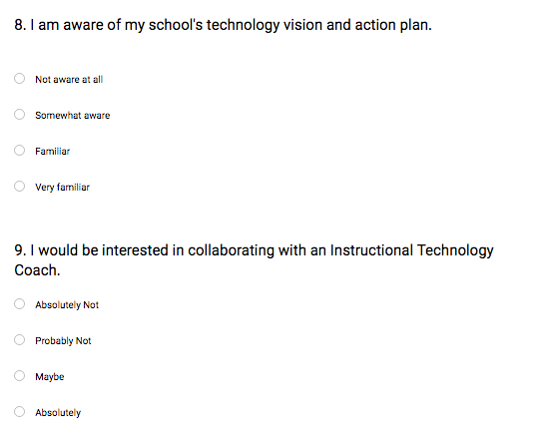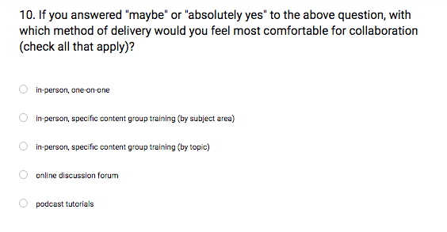
Appendix B
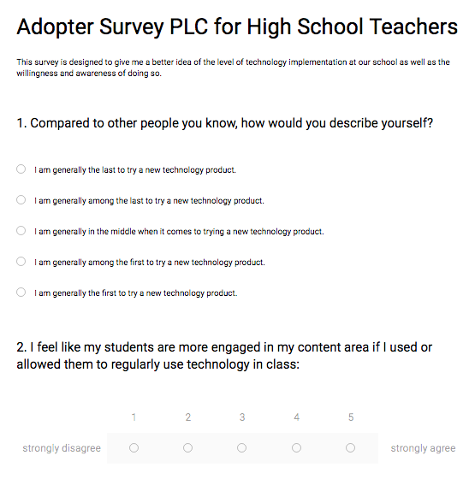
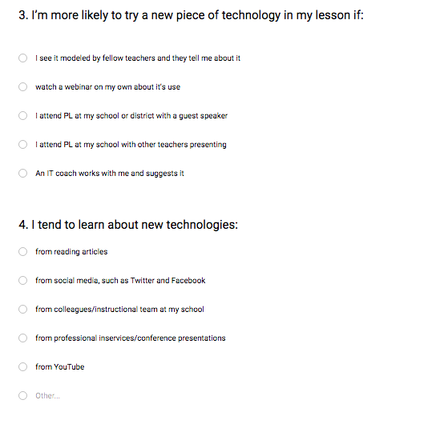
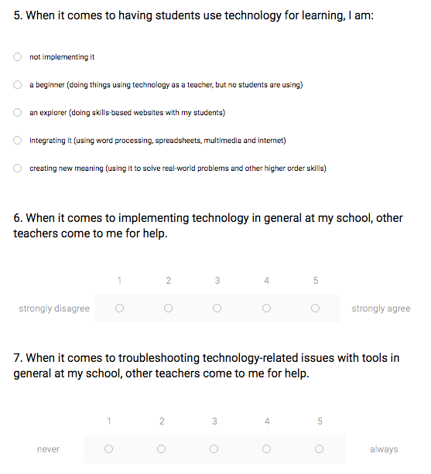
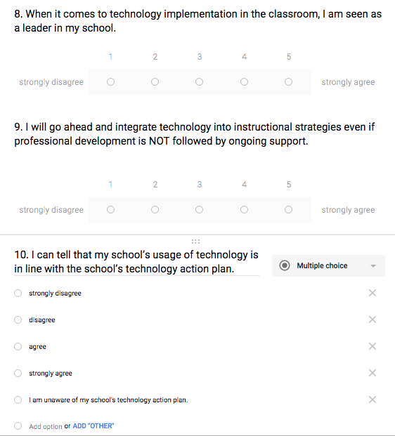

References
“Adopter Survey” Created by Jamey Bearden, Ulmer Charles, Jessica Morman, Willis Sudderth, Keith Toda

“LoTi Survey” Created by Jamey Bearden, Ulmer Charles, Jessica Morman, Willis Sudderth, Keith Toda

